**☺ ♥ ☁ ☀ ❤ ✌**

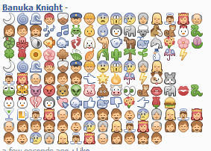-**☺ ♥ ☁ ☀ ❤ ✌**  
  
🌙🌀🌊👲👳👮👷😨😱😰👵👱👼👸👴  
👩👨👧🎶🎵👾🐥🐦🐧🐘🐑🐴🐒🐔🐍  
🐛🐙🐚🐠🐟🐾🐩🐫🐡🐎🐳🐬💐🌸🌷  
🍀🌹🌻🌺🍁🍃🍂🌾🌵🌴🌱⛄☔⚡  
🌙🌀🌊👲👳👮👷😨😱😰👵👱  
👼👸👴👩👨👧👈🌟🔥☔⚡🐶🐰  
🐸🐯👿😡🐻👽🐷💩🐮👀🐒👄🐘💋🐍  
🐔🐔💔🐧💘🐟👍🐳👎💐👉🌹🍔  
🍸🍺👼👸👴👩👨👧👦👶😰👵👱👼👸  
👴👩👨👧👦👶😰👵👱👼👸👴👩👨👧  
👦👶😰👵👱👼👸👴👩👨👧👦

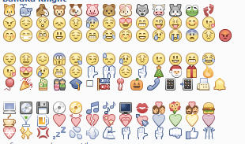

🐱 🐳 🐴 🐵 🐶 🐷 🐻 🐹 🐺 🐮 🐰 🐸 🐾

😠 😩 😲 😞 😵 😰 😒 😍 😤 😜 😝 😋 😘

😚 😷 😳 😃 😆 😁 😂 ☺ 😄 😢 😭 😨 😣 😡  
  
😌 😖 😔 😱 😪 😏 😓 😥 😫 😉 😺 😸 😹

😽 😻 😿 😼 🙀 🙋 🙌 🙍 🙏 🎄 🎅 🎁 🔥

🎈 🎉 🎍 🎎 🎓 🎒 🎏 🎐 🎃 📞 📱 📲 📠 🔔  
  
💻 💽 💾 💿 📀 🎵 🎼 📺 💋 💏 💐 💑 🍔

☕ 🍸 🍺 ❤ 💓 💔 💖 💗 💘 💙 💚 💛 💜

💝 ✨ 💢 💤 💦 💨 💪 ✊ ✋ ✌ 👊 👍 ☝

If I could get star from sky for you

I would do it twice

And only because I love you

I would reach any planet

And If feeling would be broken

I would become sailer near with island of your desires

Your desires

But inside of myself

I understand that I can't do it

And sometimes I lose myself

When I'm falling in love-

Sometimes I'm despairing, when I'm falling in love-

When I least expecting it, I'm falling in love-

Time stopping-

And soul coming to my body-

I'm smiling, when I'm falling in love-

If moon would be your award

I swear, I'd do everything to get it

And be yours

If you hear my cries in your dreams

Wake up, it's reality

It's not dream, not

And I glad that always comes a moment...

When I'm falling in love

Sometimes I'm despairing, when I'm falling in love

When I least expecting it, I'm falling in love

Time stopping

And soul coming to my body

I'm smiling, when I falling in love

When I'm falling in love-MAGE WENAWADO

Sometimes I'm despairing, when I'm falling in love-KIYANNA HEDA KELLE, MAGE WEN..

When I least expecting it, I'm falling in love-SADAA KAL RAKA, MAGE WE..

Time stopping-WEE MAGE KUMAREE

And soul coming to my body-MA DESA BALAAWEE

I'm smiling, when I'm falling in love- SINAASEE, MAGE WENAWADO